1, Set up a smart home intrusion detection system using PIR and door/window sensors. LED and buzzer alert on unauthorized access. Show the IoT setup in Tinkercad.
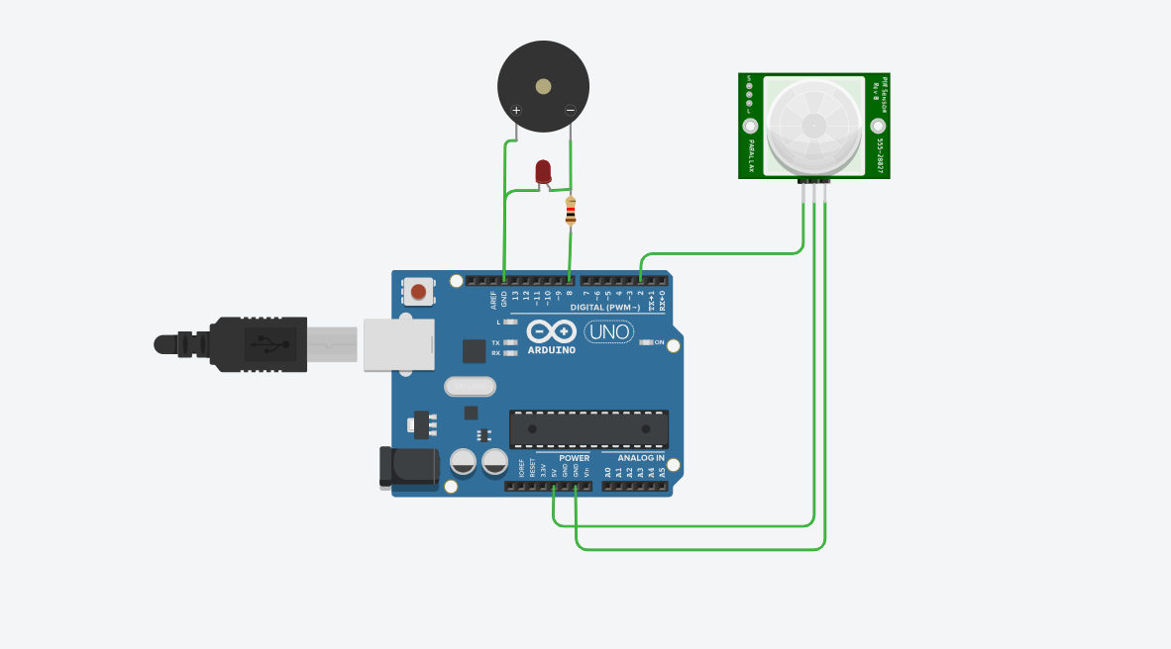
int pirPin = 2;
int doorPin = 3;
int ledPin = 10;
int buzzerPin = 11;

void setup() {
pinMode(pirPin, INPUT);
pinMode(doorPin, INPUT_PULLUP);
pinMode(ledPin, OUTPUT);
pinMode(buzzerPin, OUTPUT);
}

void loop() {
bool motion = digitalRead(pirPin) == HIGH;
bool doorOpen = digitalRead(doorPin) == LOW;

if (motion || doorOpen) {
digitalWrite(ledPin, HIGH);
tone(buzzerPin, 1000);
} else {
digitalWrite(ledPin, LOW);
noTone(buzzerPin);
}
}
2. Create a smart laboratory chemical leak alert using gas sensors. LED and buzzer alert on hazardous gas detection. Present the IoT design in Tinkercad.
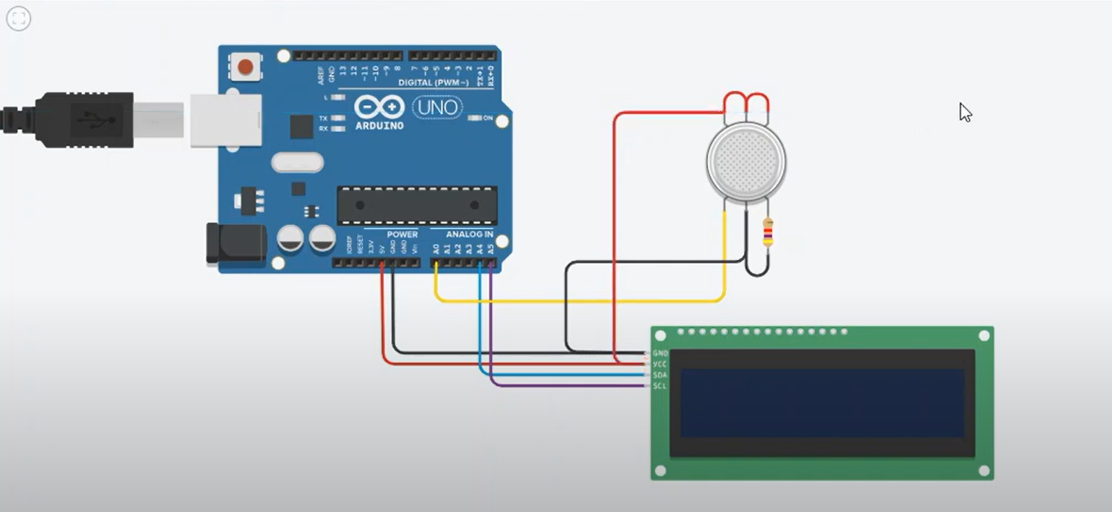
const int gasPin = A0;
const int ledPin = 10;
const int buzzerPin = 11;

int threshold = 400; // adjust for sensitivity

void setup() {
pinMode(ledPin, OUTPUT);
pinMode(buzzerPin, OUTPUT);
Serial.begin(9600);
}

void loop() {
int value = analogRead(gasPin);
Serial.println(value);

if (value > threshold) {
digitalWrite(ledPin, HIGH);
tone(buzzerPin, 1500);
} else {
digitalWrite(ledPin, LOW);
noTone(buzzerPin);
}

delay(200);
}
3. Implement a smart server power alert system using AC current sensors. LED and buzzer alert on high usage or abnormal activity. Show the IoT architecture in Tinkercad.
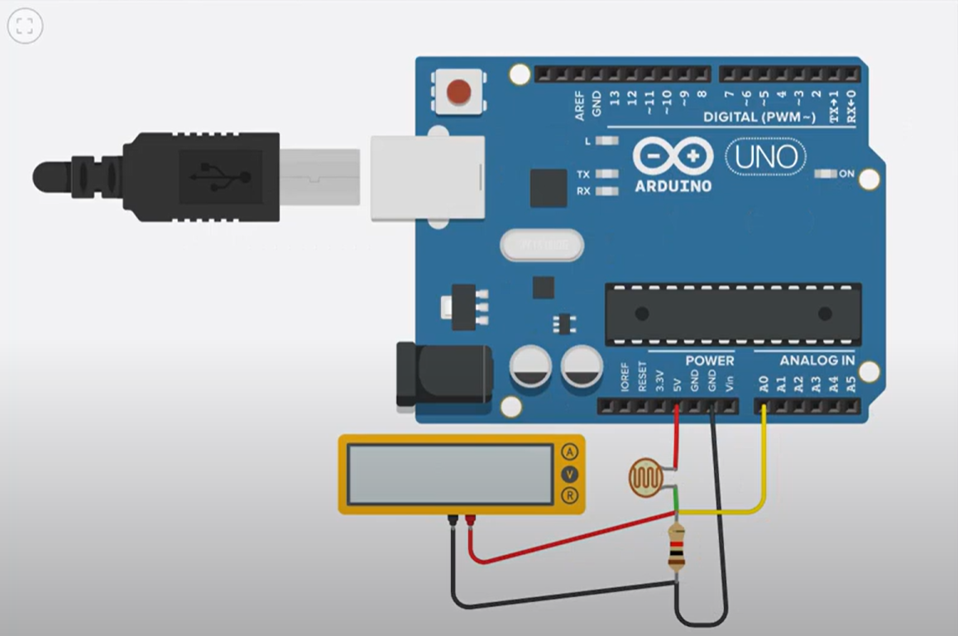
const int sensorPin = A0;
const int ledGreen = 2;
const int ledYellow = 3;
const int ledRed = 4;
const int buzzer = 5;

int currentValue = 0;
float amps = 0;

void setup() {
Serial.begin(9600);
pinMode(ledGreen, OUTPUT);
pinMode(ledYellow, OUTPUT);
pinMode(ledRed, OUTPUT);
pinMode(buzzer, OUTPUT);
}

void loop() {
currentValue = analogRead(sensorPin);
amps = currentValue * (30.0 / 1023.0);

if (amps < 10) {
digitalWrite(ledGreen, HIGH);
digitalWrite(ledYellow, LOW);
digitalWrite(ledRed, LOW);
digitalWrite(buzzer, LOW);
}
else if (amps >= 10 && amps < 18) {
digitalWrite(ledGreen, LOW);
digitalWrite(ledYellow, HIGH);
digitalWrite(ledRed, LOW);
digitalWrite(buzzer, LOW);
}
else {
digitalWrite(ledGreen, LOW);
digitalWrite(ledYellow, LOW);
digitalWrite(ledRed, HIGH);
digitalWrite(buzzer, HIGH);
}

Serial.print("Current: ");
Serial.print(amps);
Serial.println(" A");
delay(300);
}
4. Set up a smart warehouse motion detection system using PIR sensors. LED and buzzer alert on unauthorized movement. Show the IoT architecture in Tinkercad.
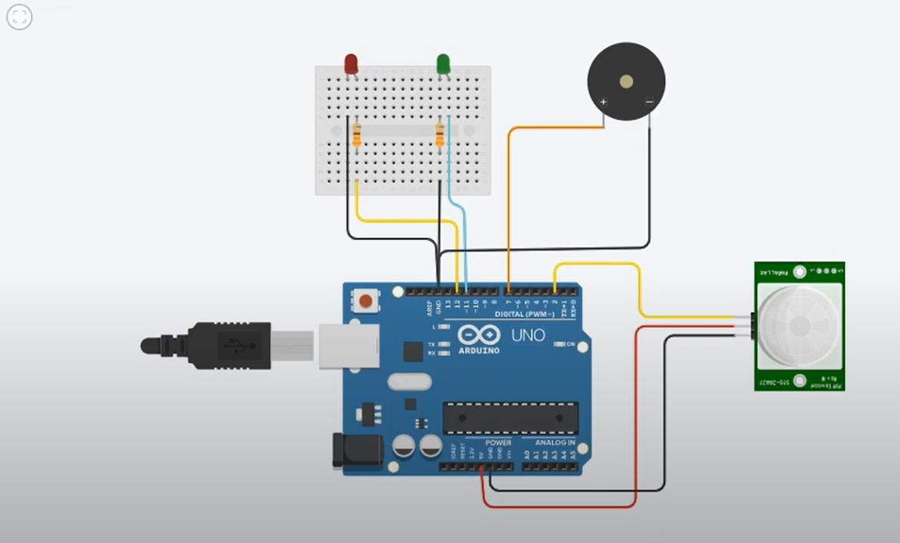
const int pirPin = 7;
const int led = 2;
const int buzzer = 3;

int motionState = 0;

void setup() {
pinMode(pirPin, INPUT);
pinMode(led, OUTPUT);
pinMode(buzzer, OUTPUT);
Serial.begin(9600);
}

void loop() {
motionState = digitalRead(pirPin);

if (motionState == HIGH) {
digitalWrite(led, HIGH);
digitalWrite(buzzer, HIGH);
Serial.println("Motion Detected");
} else {
digitalWrite(led, LOW);
digitalWrite(buzzer, LOW);
}
delay(200);
}
5. Develop a smart server room door monitor using magnetic sensors. LED and buzzer alert on unauthorized opening. Describe the IoT structure in Tinkercad.
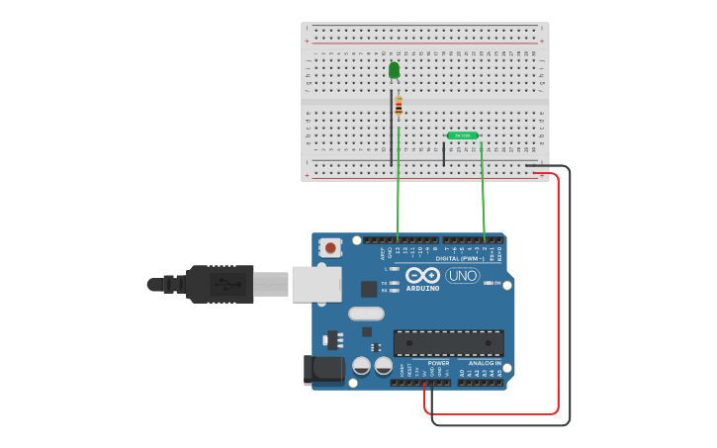
const int doorPin = 7;
const int led = 2;
const int buzzer = 3;

int doorState = 0;

void setup() {
pinMode(doorPin, INPUT_PULLUP);
pinMode(led, OUTPUT);
pinMode(buzzer, OUTPUT);
Serial.begin(9600);
}

void loop() {
doorState = digitalRead(doorPin);

if (doorState == LOW) {
digitalWrite(led, HIGH);
digitalWrite(buzzer, HIGH);
Serial.println("Unauthorized Door Opening");
} else {
digitalWrite(led, LOW);
digitalWrite(buzzer, LOW);
}
delay(200);
}
6. Implement a smart home energy monitor using AC current sensors. LED and buzzer alert on high consumption. Describe the IoT structure in Tinkercad.
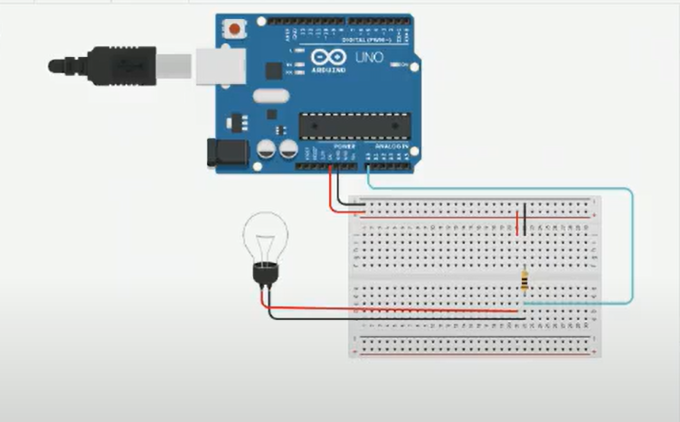
const int sensorPin = A0;
const int ledGreen = 2;
const int ledYellow = 3;
const int ledRed = 4;
const int buzzer = 5;

int currentValue = 0;
float amps = 0;

void setup() {
Serial.begin(9600);
pinMode(ledGreen, OUTPUT);
pinMode(ledYellow, OUTPUT);
pinMode(ledRed, OUTPUT);
pinMode(buzzer, OUTPUT);
}

void loop() {
currentValue = analogRead(sensorPin);
amps = currentValue * (30.0 / 1023.0);

if (amps < 10) {
digitalWrite(ledGreen, HIGH);
digitalWrite(ledYellow, LOW);
digitalWrite(ledRed, LOW);
digitalWrite(buzzer, LOW);
}
else if (amps >= 10 && amps < 18) {
digitalWrite(ledGreen, LOW);
digitalWrite(ledYellow, HIGH);
digitalWrite(ledRed, LOW);
digitalWrite(buzzer, LOW);
}
else {
digitalWrite(ledGreen, LOW);
digitalWrite(ledYellow, LOW);
digitalWrite(ledRed, HIGH);
digitalWrite(buzzer, HIGH);
}

Serial.print("Current: ");
Serial.print(amps);
Serial.println(" A");
delay(300);
}
7. Implement a smart parking lot security system using PIR and ultrasonic sensors. LED and buzzer alert on unauthorized access. Present the IoT design in Tinkercad.
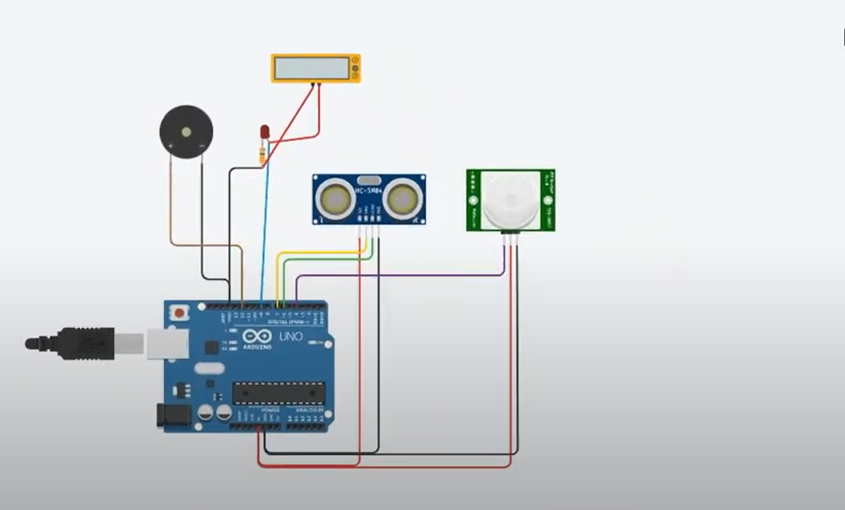
const int pirPin = 7;
const int trigPin = 8;
const int echoPin = 9;
const int led = 2;
const int buzzer = 3;

long duration;
int distance;
int pirState = 0;

void setup() {
pinMode(pirPin, INPUT);
pinMode(trigPin, OUTPUT);
pinMode(echoPin, INPUT);
pinMode(led, OUTPUT);
pinMode(buzzer, OUTPUT);
Serial.begin(9600);
}

void loop() {
pirState = digitalRead(pirPin);

digitalWrite(trigPin, LOW);
delayMicroseconds(2);
digitalWrite(trigPin, HIGH);
delayMicroseconds(10);
digitalWrite(trigPin, LOW);
duration = pulseIn(echoPin, HIGH);
distance = duration * 0.034 / 2;

if (pirState == HIGH || distance < 50) {
digitalWrite(led, HIGH);
digitalWrite(buzzer, HIGH);
Serial.println("Unauthorized Access Detected");
} else {
digitalWrite(led, LOW);
digitalWrite(buzzer, LOW);
}
delay(200);
}
8. Create a smart ATM monitoring system using PIR and magnetic sensors. LED and buzzer alert on tampering or unauthorized access. Explain the IoT layout in Tinkercad.
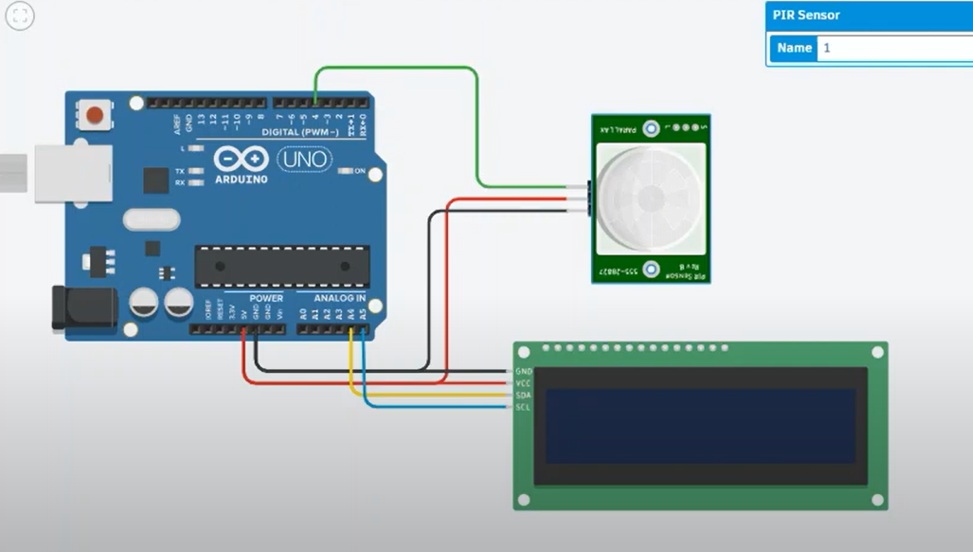
const int pirPin = 7;
const int magPin = 8;
const int led = 2;
const int buzzer = 3;

int pirState = 0;
int magState = 0;

void setup() {
pinMode(pirPin, INPUT);
pinMode(magPin, INPUT_PULLUP);
pinMode(led, OUTPUT);
pinMode(buzzer, OUTPUT);
Serial.begin(9600);
}

void loop() {
pirState = digitalRead(pirPin);
magState = digitalRead(magPin);

if (pirState == HIGH || magState == LOW) {
digitalWrite(led, HIGH);
digitalWrite(buzzer, HIGH);
Serial.println("Unauthorized ATM Access Detected");
} else {
digitalWrite(led, LOW);
digitalWrite(buzzer, LOW);
}
delay(200);
}
9. Create a smart corridor fire alert system using smoke and flame sensors. LED and buzzer alert on fire detection. Describe the IoT structure in Tinkercad.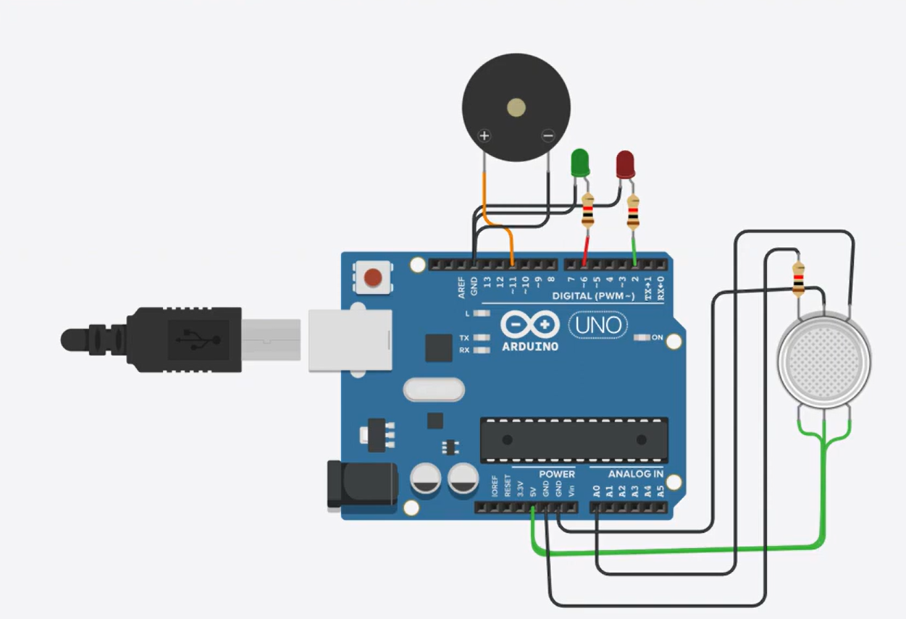
int smokePin = 2;
int flamePin = 3;
int ledPin = 8;
int buzzerPin = 9;

void setup() {
pinMode(smokePin, INPUT);
pinMode(flamePin, INPUT);
pinMode(ledPin, OUTPUT);
pinMode(buzzerPin, OUTPUT);
Serial.begin(9600);
}

void loop() {
int smokeState = digitalRead(smokePin);
int flameState = digitalRead(flamePin);

if(smokeState == HIGH || flameState == HIGH){
digitalWrite(ledPin, HIGH);
digitalWrite(buzzerPin, HIGH);
Serial.println("FIRE ALERT!");
} else {
digitalWrite(ledPin, LOW);
digitalWrite(buzzerPin, LOW);
}
delay(200);
}

